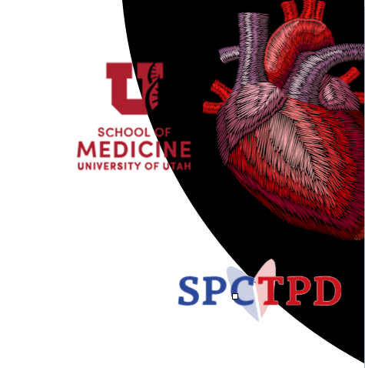
The National Academy for Fellow Career Development at
the University of Utah & Primary Children’s Hospital in
collaboration with the Society of Pediatric Cardiology Training
Program Directors (SPCTPD) invite you to:

2023 Fellows Leadership, Research & Quality Bootcamp
May 11 – 13, 2023
Salt Lake City, Utah

1.5-Day Interactive Conference
* Arrival & Dinner May 11, 2023 *
Conference May 12 – 13, 2023

Goals: Using didactics and interactive learning, fellows will be exposed to and practice:
- Skills and strategies for developing a career in leadership in Pediatric Cardiology
- Investigative skills and techniques for a successful career in research and grantsmanship
- Integrating quality improvement into clinical care and career aspirations
Online Application
Target Audience: Pediatric Cardiology Fellows from a US fellowship

Invited Faculty:
- Catherine Krawczeski, MD - Chief, Department of Pediatrics, Nationwide Children’s Hospital
- Nicholas Madsen, MD - Chief, Pediatric Cardiology, UT Southwestern
- Ritu Sachdeva, MD – Director, Cardiovascular Imaging Research Core, Emory University
- Rupali Gandhi, MD – Program Director, Pediatric Cardiology Fellowship, Advocate Children’s Heart Institute
- Lowell Frank, MD - Program Director, Pediatric Cardiology Fellowship, Children’s National Hospital
- Laurie Armsby, MD – Program Director, Pediatric Cardiology Fellowship, Oregon Health & Science University

Cost: Meeting registration, lodging and travel will be covered

